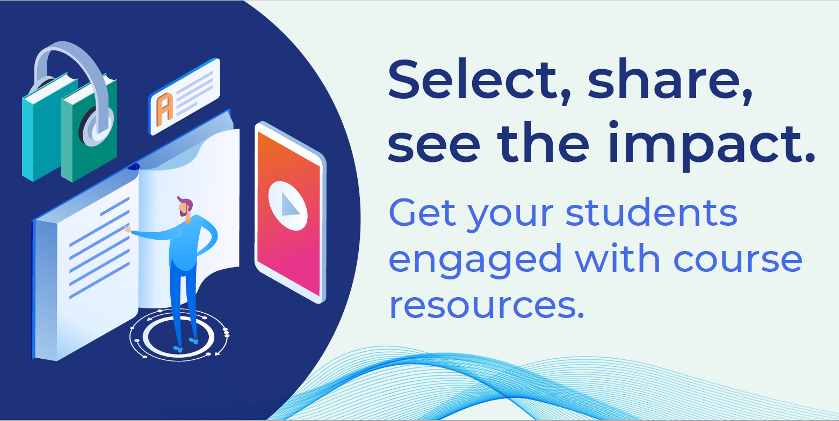
Dear FIRST NAME,
Need a better way to manage course materials? Join us on Tuesday, May 4th at 2:00 P.M. ET to see how Leganto enables you to easily assemble, manage and share course resource lists.
With Leganto, you can:

- Build course resource lists yourself or collaborate with others
- Add any kind of content, including but not limited to physical books, eBooks, eBook chapters, scholarly articles, videos, newspaper articles, OER, and more
- Allow students to easily access course resource lists from Blackboard
- Structure lists with weekly, monthly or topic based sections
- Easily roll over course resource lists from term to term, adjusting as needed
- Discuss topics/resources with students using ‘Read and Respond’

You’ll see firsthand just how much easier Leganto makes managing your course content. (And who doesn’t want course prep to be a bit easier, right?)

Register now.
Can’t make it? Register anyway and we’ll send you the recording.
Sincerely,

