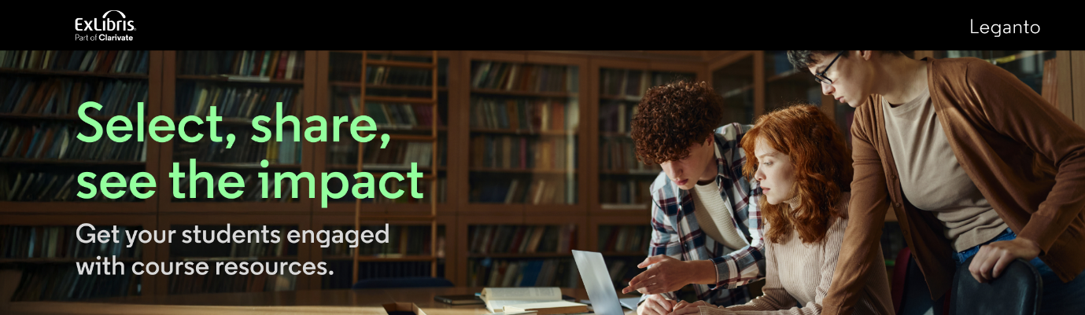

Hello, <Instructor>.

I hope this note finds you well and enjoying your week.

I want to share some information I think you might find useful

**With Leganto, instructors can:**

* create dynamic lists of citations from a range of sources - print or electronic Library resources, streaming video, websites, textbooks, journals, and more
* monitor student engagement through system analytics
* promote student engagement by enabling features that allows students to recommend resources and post comments
* easily update content and reuse elements or duplicate whole lists for other courses
* comply with applicable copyright policies
* fully leverage library subscriptions to enhance learning affordability
* allow selected collaborators to edit and manage lists

**With Leganto, students can:**

* find all of their course readings in one place, recommend resources, and post comments for discussion
* access resoures directly from the LMS – no separate log-in credentials needed, no broken links, mobile friendly
* have direct access to articles via the Leganto citation link
* save money with reading lists that greatly leverage library and campus funded materials as well as open web content.

Please reach out to me with any questions or feedback. I am here to assist and am excited to get your input as we move forward.

Warmest regards,

< Librarian>